Deliverable 3

SEG2105

Group Members:

Christopher Francis (8661478)

Kevin Power-Peacock(8586032)

Benjamin Vokey(8649554)

Thomas Scott Fulton(8765062)

Deliverable 3: User Interface

* A nonfunctional UI of the application

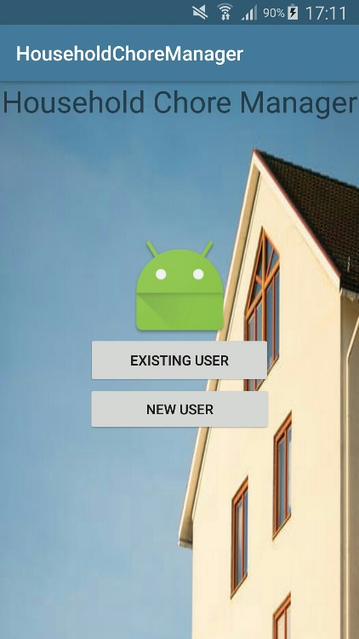

Startup

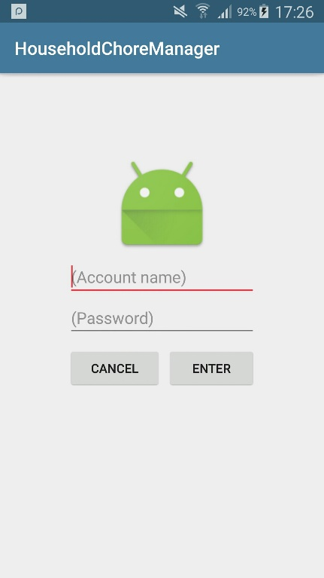

Login

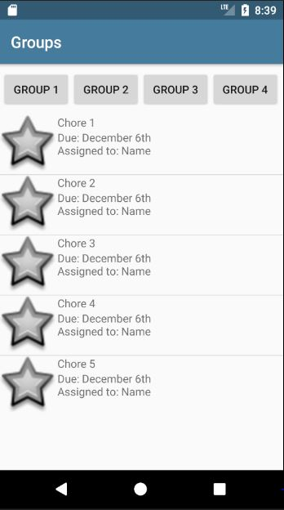

Groups

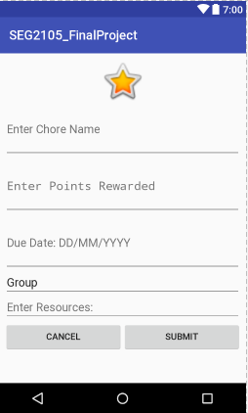

Create New Chore

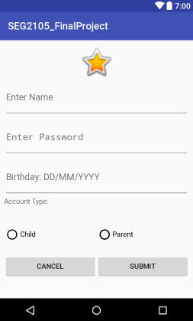

Create Account

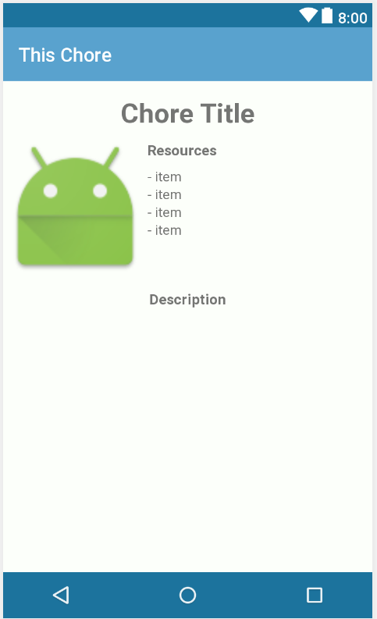

Description of Chore

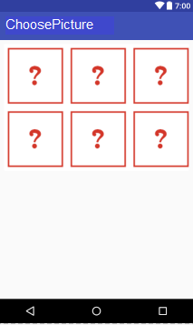

Choose what category the chore is in

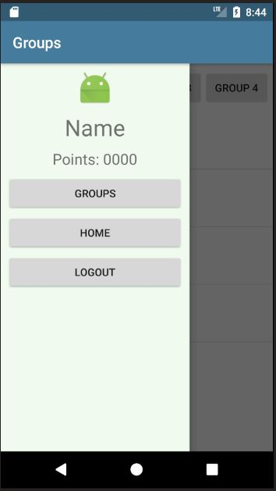

Navigation Menu

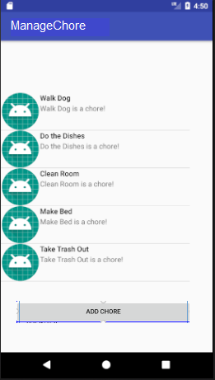

Manage Chores